Chapter 1. Introduction to Artificial Intelligence
Table of Contents

Chapter 1. Introduction to Artificial Intelligence: Intelligent Agents and Problem-Solving by Search
Every time a phone shows directions in a moment, and every time an email quietly lands in the spam folder instead of the inbox, a decision has been made on someone’s behalf. Behind both sits the same core idea: a system that looks at its situation and chooses an action that moves it toward a goal. This chapter introduces that idea, the intelligent agent, together with the technique it most often relies upon, search.
We begin from a problem that machines are already trusted to solve, finding a good route between two places, and use it to uncover what the word intelligence can mean in a form precise enough to program. From there the chapter builds up steadily. It defines what artificial intelligence is, describes how an agent and its environment interact, shows how to state a problem in a way a computer can work on, and then studies the classical search methods that power navigation apps, games, robots, and a great deal more. By the end, the aim is not that these ideas have been memorised, but that they feel natural enough to be reconstructed from first principles.

1.1 The Problem: Why Does a Maps App Always Find a Good Route?
Open any maps application. Enter a starting point and a destination. In about a second, out of the enormous number of ways to travel between those two places, it returns a fast one, sometimes even avoiding a traffic jam that formed only minutes ago.
It is worth pausing on how surprising that is.
A city has thousands of roads, and each road connects to several others. The number of possible routes between two points grows so quickly that writing them all out is hopeless. Yet the answer appears almost instantly.
How is that possible?
The application does not examine every route. It cannot, because doing so would take impossibly long. Instead it searches carefully. It follows the promising directions, sets aside the hopeless ones, and stops as soon as it can be sure the best answer has been found.
That single skill, exploring a vast space of possibilities in a careful rather than exhaustive way, is the subject of this chapter. And there is a pleasing surprise waiting inside it. The same idea that finds a route to college also lets a chess program challenge a champion, lets a delivery app plan a rider’s path, and lets a cleaning robot move around a sofa. One idea serves a thousand purposes.
Key idea. In artificial intelligence, intelligence is very often careful searching: exploring a space of possible solutions without wasting effort on the poor ones. Understanding search means understanding the core of classical AI.

1.2 A Familiar Example: Finding a Classroom on the First Day
Set maps and satellites aside for a moment and picture a first day on a new campus.
The instruction is simple: the class is in Room 214, Block C. The place is unfamiliar, there is no map, and the starting point is the main gate. What does a person actually do?
They explore. They walk to a junction and see three corridors. They choose one; it leads to Block A, which is wrong, so they return. They try a second corridor; it heads toward Block C, which feels closer, so they continue, always favouring the direction that seems nearer to the goal, until they arrive.
Notice the four things that happened naturally.
- The walk began somewhere definite, the gate. Call this the start state.
- There was a target, Room 214. Call this the goal state.
- At each junction there were choices, namely which corridor to take. Call these the actions.
- There was a feeling of “this way seems closer” that guided the choice. Call this a heuristic, meaning a rough guide or estimate that helps decide where to look next.
That process is a search, and it is essentially what a computer does inside a maps application. The one difference is that the computer works with numbers where a person works with a feeling. Much of this chapter is about turning that feeling, “this corridor seems closer”, into precise steps a machine can follow.
Key idea. Searching is already a familiar skill; people use it every day. The task here is to write down clearly what the mind does informally, in a form a computer can carry out.

1.3 Thinking About the Problem Before Any Formula
Before writing anything mathematical, it helps to think about what the search for Room 214 really involved. Three questions bring out the structure.
The first question is: what am I trying to make small? The goal was the shortest walk, so a number is attached to every route, its length, and the aim is to make that number as small as possible. This hidden number is the seed of everything that follows, and it will soon be named the path cost.
The second question is: what do I know at each moment? Only two things, really, where I am standing right now, and which corridors lead away from it. So a description of the current place, together with the choices available there, is enough to capture the situation.
The third question is: what must I still guess? The exact remaining distance to Block C is unknown, but a reasonable estimate is possible, such as “Block C is roughly that way, about fifty metres”. That estimate is a guess about the future, and it is exactly the heuristic mentioned earlier.
Three ideas are now in hand: a cost to make small, a current situation that is known, and an estimate that is guessed. Every search method in this chapter is simply a disciplined way of combining these three. With that in mind, it is time to make them precise.

1.4 What Artificial Intelligence Actually Is
With the problem in view, the field itself can be defined.
Ask ten people what AI is and the answers will range across robots, chatbots, self-driving cars, and machines from films. Most of these answers are partial or mistaken, so a cleaner definition is worth building.
Historically, definitions of AI divide along two questions. Do we care about how a system thinks, or about how it acts? And do we judge it against human behaviour, or against an ideal of rationality, meaning doing the right thing? Placing these two questions on a grid gives four views.
 | Judged against humans | Judged against rationality (the ideal)
Thinking | Systems that think like humans (cognitive science) | Systems that think rationally (logic, the “laws of thought”)
Acting | Systems that act like humans (the Turing Test) | Systems that act rationally (rational agents)
For this book, and for most of modern AI, the most useful view is the one in the lower-right cell.
Artificial intelligence is the study and construction of rational agents: systems that perceive their environment and take actions expected to achieve their goals as well as possible.
The wording repays attention. The machine is not required to think like a human, and it is not required to be conscious. It is only required to do the right thing given what it knows. A thermostat that holds a room at 24 °C is, in a very small way, rational. A large language model choosing a helpful next word is rational on a much larger scale. Both are agents.
One of the four cells above carries a famous name that deserves a proper explanation, since it will appear again.

The Turing Test, Explained
In 1950 the British mathematician Alan Turing proposed a way to sidestep the endless argument about whether a machine can truly “think”. He suggested a practical test, which he called the imitation game and which is now known as the Turing Test.
Picture a person seated at a keyboard in one room. In another room are two hidden partners exchanging typed messages with that person. One partner is a human being; the other is a machine. The person may ask anything at all, on any topic, for as long as they like, and both partners reply only in text so that voice and appearance give nothing away. After a long conversation, the person is asked to say which partner was the machine. If they cannot tell reliably, doing no better than a guess, then the machine is said to have passed the test.
Turing’s insight was to replace a vague question, “can a machine think?”, with a concrete one that can actually be checked, “can a machine behave in conversation so much like a person that an observer cannot tell the difference?”. The test measures behaviour rather than inner experience, which is why it belongs in the “acting like a human” cell of the grid.

Where AI Came From
AI is not a single invention. It is a meeting point of several older subjects, and seeing them explains why the field leans so heavily on mathematics.
Philosophy contributed logic and the idea that reasoning can be mechanical, that thought might follow fixed rules, an idea traceable to Aristotle around 350 BCE. Mathematics contributed formal logic, probability for handling uncertainty, and the theory of computation. Economics contributed decision theory, the study of choosing actions that yield the best expected payoff. Neuroscience offered a working example of intelligence in the brain and its neurons. Psychology framed humans and animals as processors of information. Control theory studied systems that regulate themselves to reduce error, such as a thermostat or an automatic pilot. Linguistics supplied the structure of language, which later powers natural language processing, the subject of Chapter 4. Each of these grows into its own body of mathematics later in a degree, and AI is where they combine to do something useful.

A Short History
Dates are not worth memorising, but the rhythm of the field is worth feeling. It has moved in waves: a burst of optimism, then disappointment when promises went unmet, then a larger burst built on firmer ground.
1943 McCulloch and Pitts propose the first mathematical model of a neuron
1950 Alan Turing asks "Can machines think?" and describes the Turing Test
1956 The Dartmouth meeting coins the term "Artificial Intelligence"
1960s Search and logic-based AI; early optimism
1970s The first "AI winter": promises unmet, funding withdrawn
1980s Expert systems (rule-based AI) find use in industry
1990s Machine learning rises; a chess program defeats a world champion (1997)
2010s Deep learning advances rapidly across vision and games
2020s Large language models bring AI into everyday use
Two events from this timeline come up often. The term “artificial intelligence” was introduced at the Dartmouth meeting of 1956, organised by John McCarthy, and the Turing Test was described by Alan Turing in 1950.

1.5 Agents and Environments
Almost everything in AI is described in terms of an agent acting within an environment. This is the central picture of the subject, so it is worth drawing.
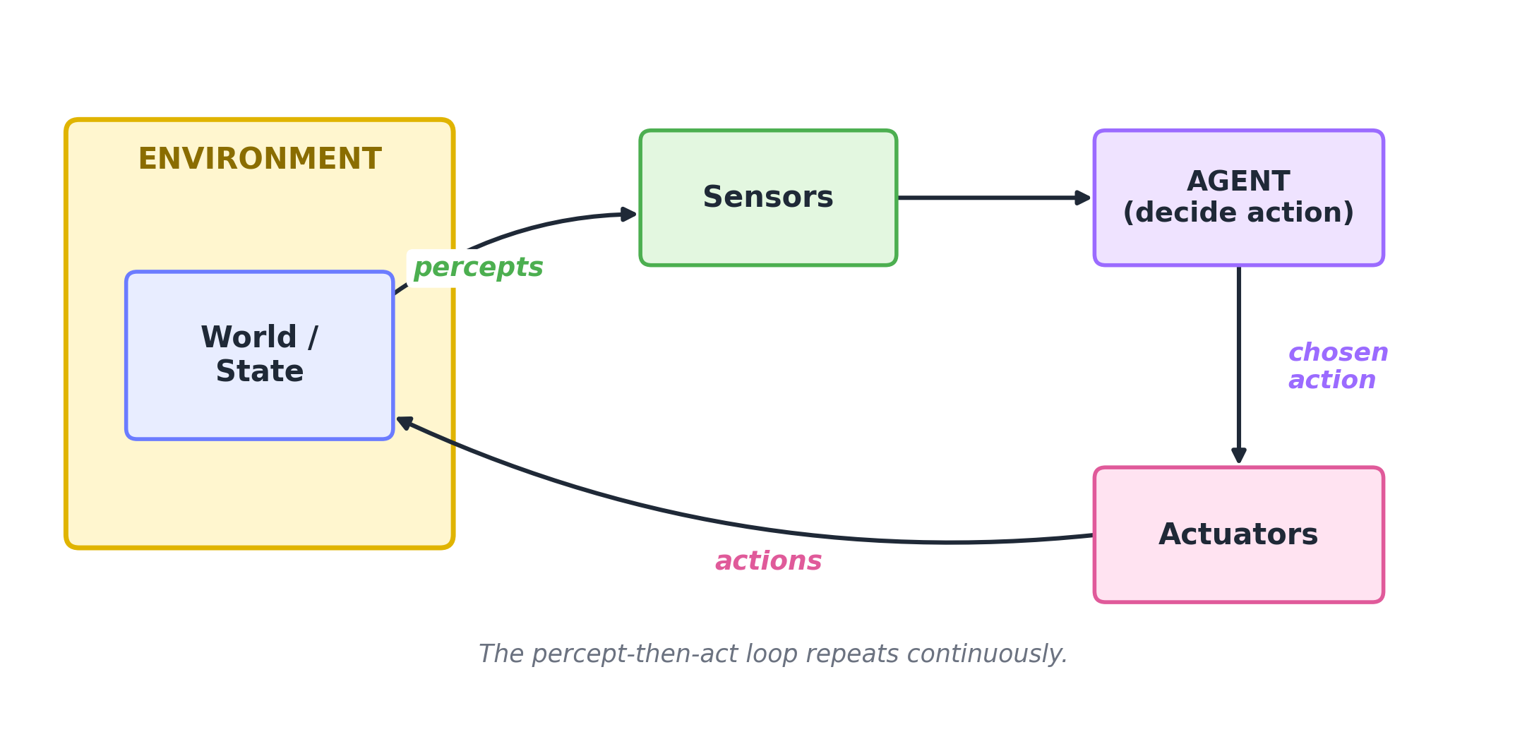
Figure 1.1. The agent and its environment, and the loop that connects them.
The loop runs clockwise. The environment is the world the agent lives in, such as the road network, the chessboard, or the room. The agent’s sensors deliver percepts, meaning whatever the agent currently observes, such as a location reading, a camera image, or the state of a board. The agent is the decision-making part, which takes what it has observed and chooses what to do. The actuators then carry out the chosen action, which changes the environment, and the loop begins again.
Stated formally, an agent is a function:
$$f:P^{*}→A$$
The symbols are worth unpacking one at a time. Here $P$ is the set of all possible percepts, that is, everything the agent could observe. The notation $P^{*}$, read “sequences of $P$”, stands for the whole history of percepts observed so far. The set $A$ contains all possible actions. And $f$ is the agent function: given everything observed up to now, it returns the action to take.
That is the whole idea. An agent is a function from a history of perception to an action. A self-driving car, a chess program, and a spam filter are simply three different choices of $f$. Much of AI is the craft of designing good agent functions.

When Is an Agent Rational?
A rational agent is one that, for every possible sequence of percepts, chooses the action expected to do best according to a stated measure of success, using the evidence from its percepts together with whatever knowledge is built into it.
Four ingredients settle what “doing best” means, and they are easy to remember by the word PEAS: Performance, Environment, Actuators, Sensors.
Letter | Meaning | Example: a self-driving taxi
P | Performance measure, how success is scored | Safety, lawful driving, speed, comfort, profit
E | Environment, where it operates | Busy roads, traffic, pedestrians, weather
A | Actuators, how it acts | Steering, accelerator, brake, horn, indicators
S | Sensors, how it perceives | Cameras, laser range-finders, location sensor, speedometer
Key idea. Before designing any AI system, write down its PEAS. Without a clear performance measure, there is no way to say whether the agent is doing well, because rationality always means rationality relative to some measure of success.
A common misconception. Rational does not mean perfect or all-knowing. A rational agent can still fail; if a truck unexpectedly falls from a bridge ahead, no amount of good reasoning could have foreseen it. Rationality is about making the best decision from the information available, not about being infallible.

The Nature of the Environment
Not all environments are equally difficult, and AI classifies them along a few axes. Knowing these axes gives a quick sense of how hard a problem will be.
Property | Easier form | Harder form | Example of the harder form
Observability | Fully observable (everything is visible) | Partially observable (some information hidden) | Card games where opponents’ cards are hidden
Determinism | Deterministic (an action has a sure result) | Stochastic (an action has an uncertain result) | Driving on a wet road
Episodes | Episodic (each step stands alone) | Sequential (now affects later) | Chess, where every move has lasting effect
Change | Static (the world waits) | Dynamic (the world changes while you think) | Live traffic
Values | Discrete (finite, separate steps) | Continuous (smoothly varying values) | The angles of a robot arm
Participants | Single agent | Multiple agents (competing or cooperating) | Team sports, financial markets
As a worked classification, consider a game of chess against another person. It is fully observable, because both players see the whole board; deterministic, because a legal move leads to a definite position; sequential, because early moves shape later ones; effectively static, though a clock adds mild time pressure; discrete, because positions and moves are separate and countable; and multi-agent, because an opponent is trying to win. Working through two or three systems in this way makes the vocabulary comfortable.
For the rest of the chapter, life is kept simple by studying environments that are fully observable, deterministic, discrete, static, and single-agent. In such a clean world the agent always knows where it is, every action has a sure result, and a complete plan can be worked out before acting. This is precisely the setting in which search applies, and search is the main subject ahead.

1.6 Problem-Solving Agents and Problem Formulation
An agent that plans a sequence of actions before acting is called a problem-solving agent. A maps application is one such agent, since it computes the entire route before the journey begins.
A computer cannot search a vague wish such as “get me to college”. The messy real situation must first be translated into a precise object. This translation is called problem formulation, and doing it well is half of the work.
A search problem is defined by five components. Learning these five is worthwhile, because every search question is assembled from them.
- The initial state, where the agent starts, such as standing at the gate.
- The actions, meaning the legal moves available in each state, such as taking corridor one, two, or three.
- The transition model, which says what state results from taking an action in a state. It is written $\text{Result}(s,a)=s′$, read as “the result of doing action $a$ in state $s$ is the new state $s′$”. For example, taking corridor two from the gate leads to junction B.
- The goal test, a way to check whether a state is a goal, such as asking “is this Room 214?”.
- The path cost, a number that measures how expensive a route is, such as total distance, time, or money. Usually the cheapest route is wanted.
Together, the initial state, the actions, and the transition model define the state space, the collection of all states reachable from the start. It is natural to picture the state space as a graph, in which states are points, called nodes, and actions are the links between them, called edges.

A Worked Example: A Small Road Map
Suppose the starting city is Arad and the destination is Bucharest. Cities are joined by roads whose lengths are given in kilometres. A small piece of such a map looks like this.
140 99
Arad ----------- Sibiu ---------- Fagaras
| | |
118| 80| |211
| | |
Timisoara Rimnicu ---------- Pitesti ------ Bucharest
97 101
The five components take concrete form. The initial state is “in Arad”. The actions are the drives to directly connected cities. The transition model says, for instance, that driving from Arad to Sibiu results in being “in Sibiu”. The goal test asks whether the current city is Bucharest. The path cost is the total of the road lengths along the route.
The problem is now fully precise, and a machine can work on it. The everyday question “how do I reach Bucharest cheaply?” has become “find the least-cost path from Arad to Bucharest in this weighted graph”. Turning a real situation into clean structure in this way is the single most valuable habit to develop, because once the formulation is right, the method is often the easy part.
Key idea. Problem formulation is the bridge from the real world to a form a computer can handle. Most of the effort in applying AI goes into choosing the five components well.

Trees, Frontiers, and the One Decision That Matters
Given a state-space graph, how does a machine explore it? It grows a search tree.
The root of the tree is the initial state. To expand a node means to apply all of its legal actions and thereby generate its neighbouring nodes, called its children. The set of nodes that have been generated but not yet expanded is called the frontier, the leading edge of the exploration. The machine repeatedly takes a node from the frontier, tests it against the goal, and expands it, continuing until a goal is found or the frontier is empty.
The idea is clearer in a picture. The next figure expands Arad, and then expands one of its children, Sibiu.
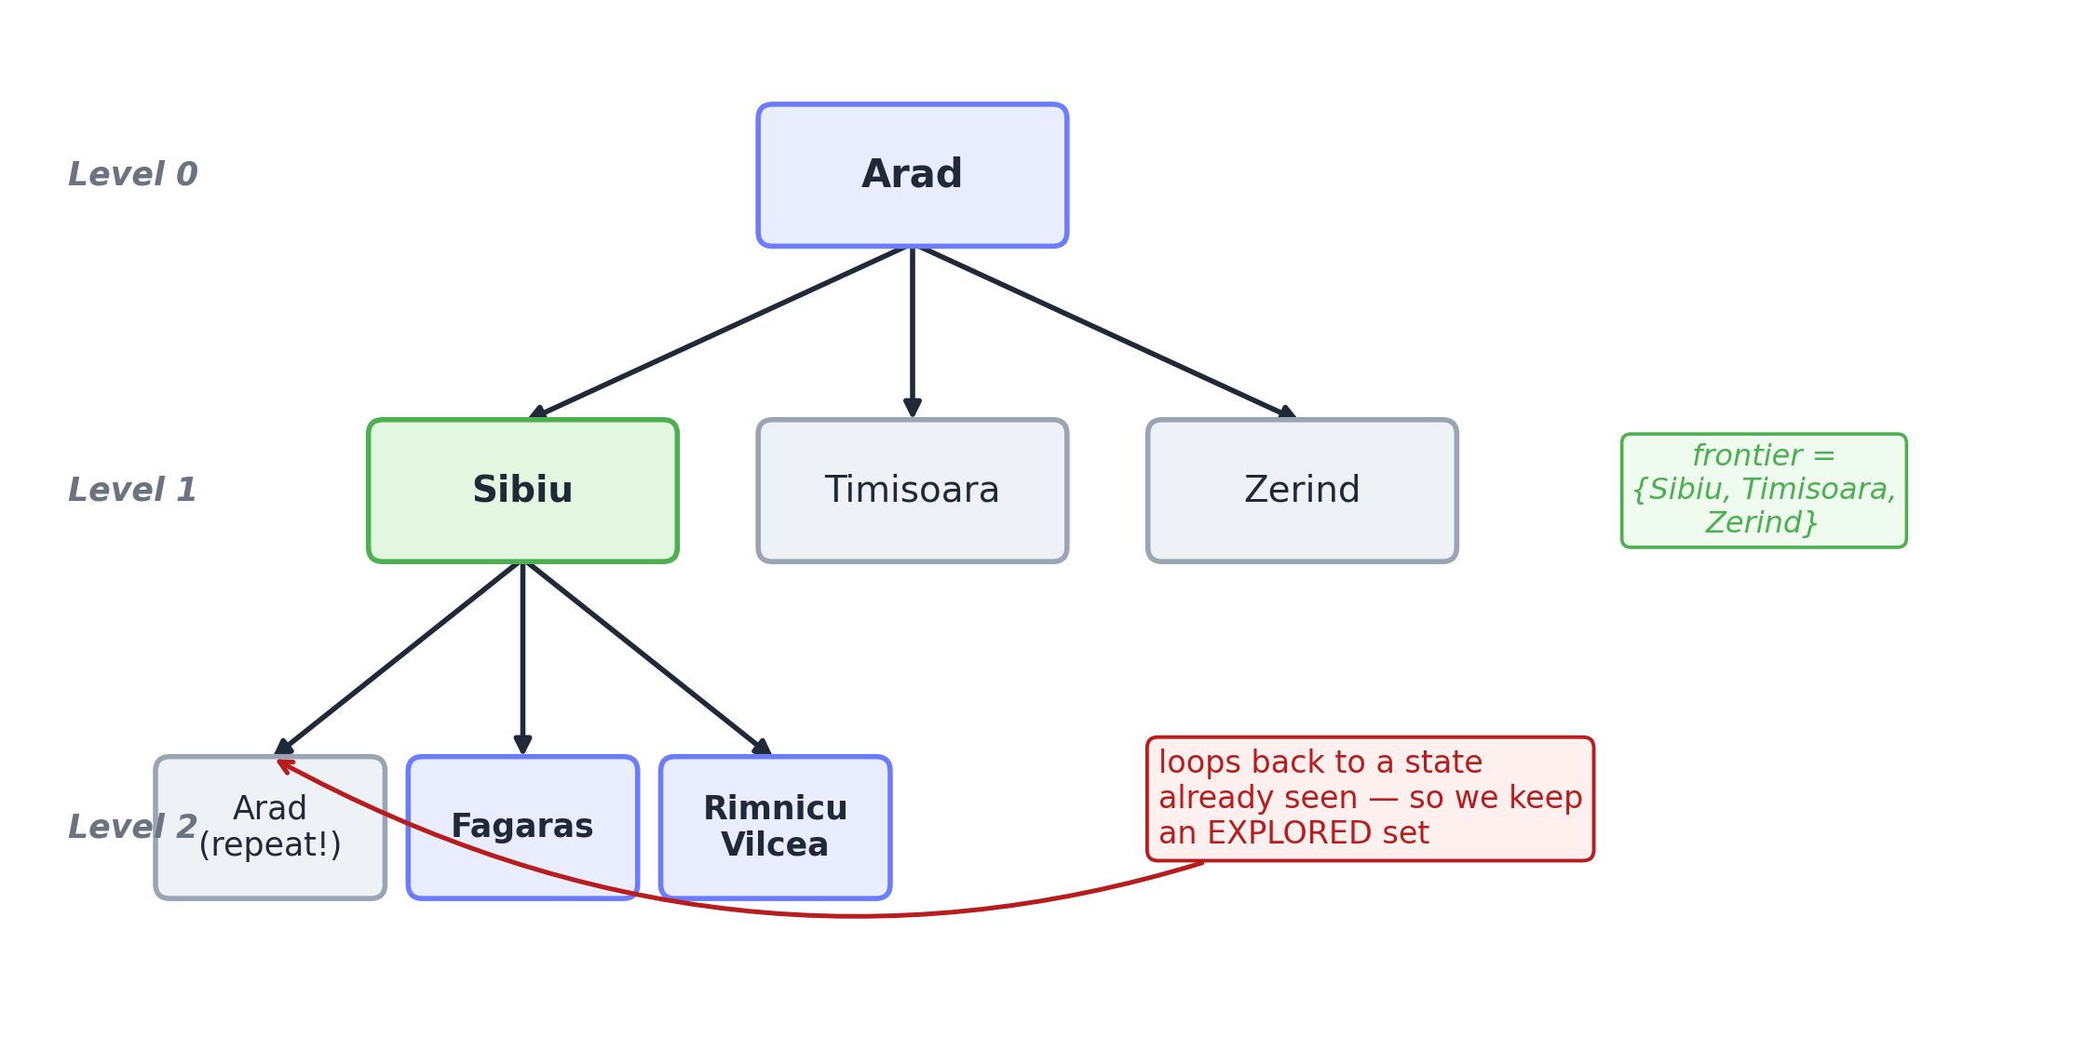
Figure 1.2. Growing a search tree. Expanding Arad produces the frontier {Sibiu, Timisoara, Zerind}. Expanding Sibiu produces Arad once more, a state already seen.
Notice the node on the lower left. Arad has appeared a second time. If the tree is followed blindly, the search can circle back to where it came from and loop forever. To prevent this, a careful search keeps an explored set, a record of the states already visited, and refuses to expand any state twice.
Only one decision separates one search method from another:
Which node should be taken from the frontier next?
That single choice produces every classical search method. They are introduced next.

1.7 Uninformed Search: Exploring Without a Hint
Uninformed search, also called blind search, means the agent has no extra clue about which state is closer to the goal. It knows only the problem definition, and it explores in a systematic way. Four such methods are essential.
A few standard symbols appear throughout, and it is worth meeting them once.
Symbol | Meaning
$b$ | the branching factor, the largest number of children any node can have
$d$ | the depth of the shallowest goal, how many steps down the nearest solution lies
$m$ | the maximum depth of the search tree, which can be infinite
$C^{*}$ | the cost of the optimal, that is cheapest, solution
$ϵ$ | the smallest cost that any single step can have
Sizes below are written using the “order of” notation, $O(⋅)$. This notation reports how a quantity grows while ignoring constant factors, so that $O(b^{d})$ means the count grows in step with $b$ raised to the power $d$.
Four properties are used to judge every method. Completeness asks whether the method is guaranteed to find a solution when one exists. Optimality asks whether it finds the cheapest solution. Time counts how many nodes are generated. Space counts how many nodes must be held in memory at once.

Breadth-First Search: Level by Level
Breadth-first search, or BFS, always expands the shallowest node that has not yet been expanded. It finishes an entire level before moving deeper. To achieve this, the frontier is kept as a first-in, first-out queue, often shortened to FIFO queue, meaning the node that has waited longest is served first, exactly like a line at a counter where the earliest arrival is attended to first.
Why is BFS both complete and optimal? Because it never skips a level. If the nearest goal lies at depth $d$, BFS is certain to reach it once depth $d−1$ has been fully explored. And because it always reaches shallow goals before deep ones, it returns a solution using the fewest steps. That last point makes it optimal only when every step costs the same.
The cost can be worked out rather than memorised. At depth 0 there is 1 node. Each node has up to $b$ children, so depth 1 holds up to $b$ nodes, depth 2 holds up to $b^{2}$, and so on down to $b^{d}$ at depth $d$. Adding these gives a geometric series:
$$1+b+b^{2}+⋯+b^{d}=\frac{b^{d+1}−1}{b−1}=O(b^{d}).$$
BFS must store every node it generates, both to maintain the queue and to trace the route back once the goal is found, so its time and its space are each $O(b^{d})$.
The left panel of Figure 1.3 shows the order in which BFS visits nodes: it sweeps across each level before descending.
Note. BFS is often described as slow, but its real difficulty is memory, not time. With a branching factor of 10 and a goal at depth 12, BFS may need to store around ${10}^{12}$ nodes, which is an enormous amount of memory. In practice BFS tends to exhaust memory long before it runs out of time.

Depth-First Search: Deep, Then Back
Depth-first search, or DFS, always expands the deepest node available. It plunges down a single path to the bottom, and only when it reaches a dead end does it backtrack, meaning it returns to the most recent junction and tries another branch. The frontier is kept as a last-in, first-out stack, often shortened to LIFO stack, meaning the most recently added node is taken first, exactly like a stack of plates where the top plate is removed first.
The trade-off is about memory. DFS needs to remember only the current path together with the unexplored siblings along it, which is $O(bm)$ space, far less than the $O(b^{d})$ demanded by BFS. That thrift is why DFS is favoured when memory is scarce. The cost of this thrift is twofold. DFS is not optimal, because it returns the first path it happens to reach rather than the cheapest, and it is not complete in an infinite space, because it can descend an endless branch and never return. Its time is $O(b^{m})$, which can be far worse than BFS when the tree is much deeper than the nearest goal.
The right panel of Figure 1.3 shows DFS visiting nodes in a different order from BFS: it dives to the bottom of a branch before considering the branch beside it.
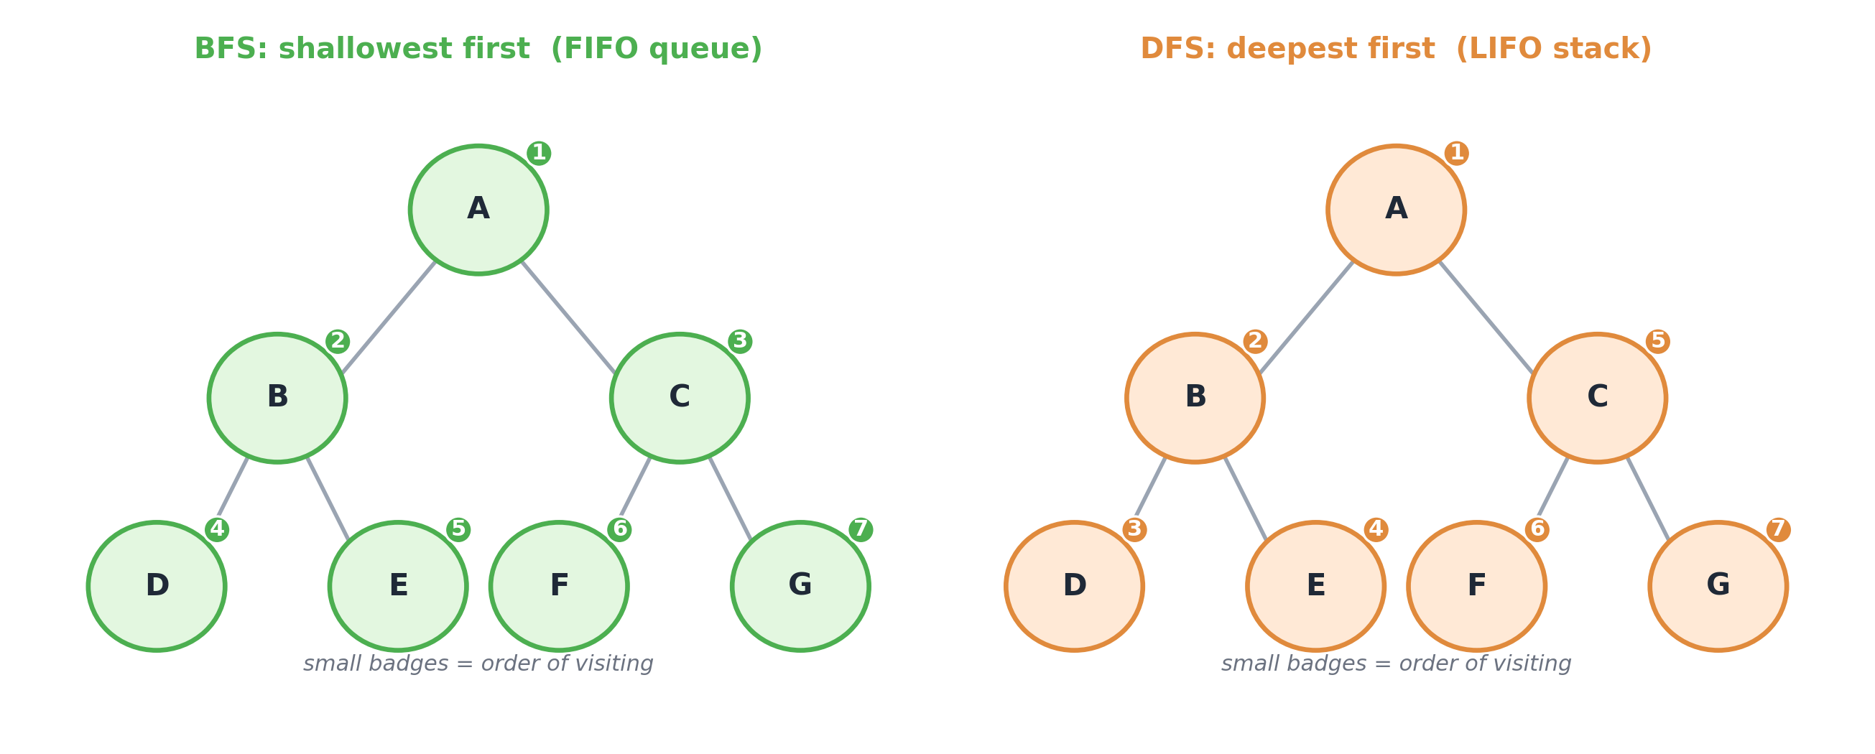
Figure 1.3. Breadth-first search visits level by level, using a queue. Depth-first search dives deep and then backtracks, using a stack. The small numbers give the order in which nodes are visited.

Uniform-Cost Search: Cheapest First
BFS is optimal only when all steps cost the same, yet roads have different lengths. Uniform-cost search, or UCS, removes that restriction. Instead of expanding the shallowest node, it expands the node with the lowest total path cost so far, written $g(n)$. The frontier is kept as a priority queue, meaning a queue that always serves the item with the smallest value of $g$ first, rather than the one that has waited longest.
$$g(n)=\text{the total cost of the path from the start to node }n.$$
UCS is complete and optimal for any non-negative step costs, provided every step costs at least some amount $ϵ$ that is greater than zero. Here $ϵ$, the Greek letter epsilon, stands for the smallest cost any single step is allowed to have. The requirement that it be strictly positive matters: if steps were permitted to cost nothing, the search could drift through endless free moves without making real progress, and the guarantee of finding the cheapest route would collapse. UCS is, in effect, the same procedure as Dijkstra’s algorithm, a classical method for shortest paths in a weighted graph that appears in the study of algorithms.
Figure 1.4 shows UCS at work on a small graph. Each node is labelled with its cost from the start, $g$, and the small badges give the order of expansion. Because UCS always expands the least-cost node next, it can settle on a route with more steps when that route is cheaper overall.
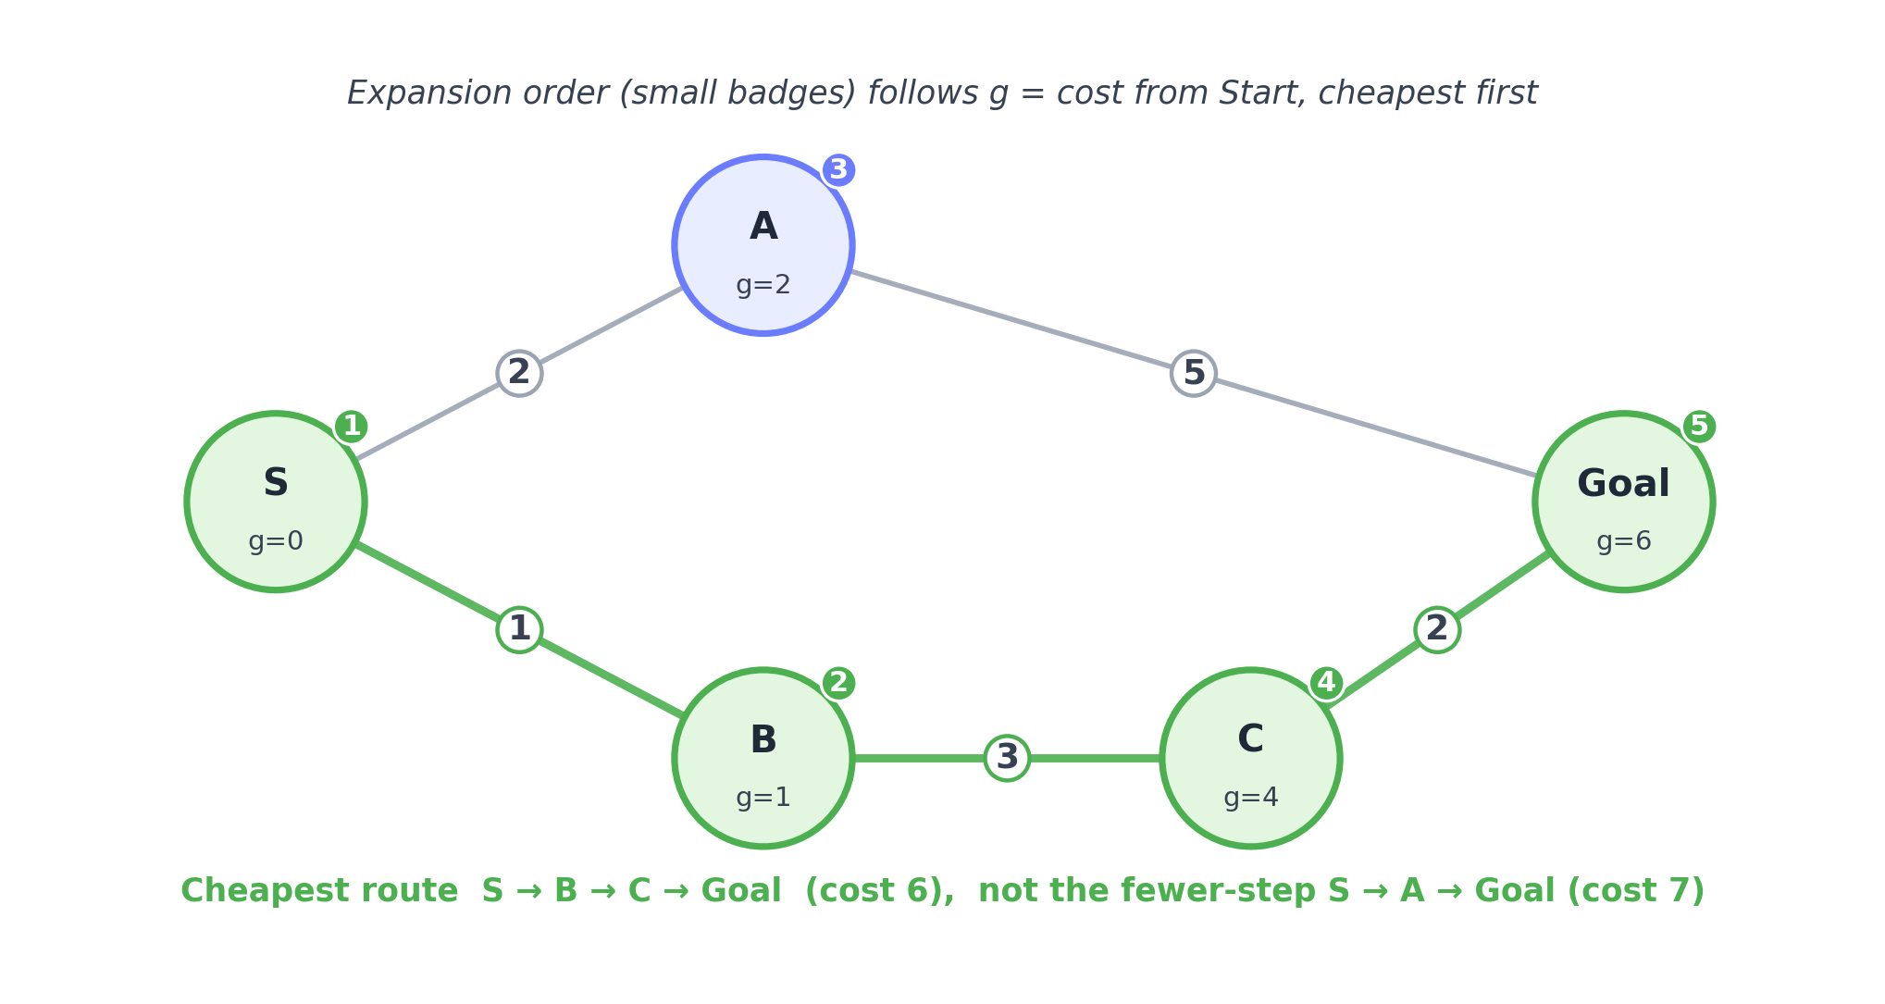
Figure 1.4. Uniform-cost search expands nodes in increasing order of $g$, the cost from the start. It returns the route Start, B, C, Goal at cost 6, rather than the fewer-step route Start, A, Goal at cost 7.
The cost of UCS is best written in terms of solution cost rather than depth, as $O​\left(b^{ 1+⌊C^{*}/ϵ⌋}\right)$. Read this as saying that if the cheapest solution costs $C^{*}$ and the smallest step costs $ϵ$, then the effective depth of the search is about $C^{*}/ϵ$. The point to carry away is that UCS can explore more widely than BFS, because it keeps following cheap paths even when they grow long.

Iterative Deepening Search: The Best of Both
Is it possible to keep the tiny memory of DFS while regaining the completeness and optimality of BFS? It is, through a simple idea. Run DFS but forbid it to go deeper than level 0. If that fails, run DFS again with the limit raised to level 1. If that fails, raise the limit to level 2, and so on, deepening by one level each round. This method is called iterative deepening search, or IDS.
At first this seems wasteful, since the upper levels are explored again in every round. The surprise is that the waste is slight. The deepest level contains by far the most nodes, about $b^{d}$ of them, and it is explored only once, in the final round. Only the small upper levels are repeated. Counting carefully, the total number of nodes generated is
$$\sum_{i=0}^{d}{(}d−i+1) b^{i}=O(b^{d}),$$
the same order as BFS, while the memory needed is only $O(bd)$, as thrifty as DFS.
Figure 1.5 shows the first three rounds. Each round is a fresh, depth-limited search starting again from the root.
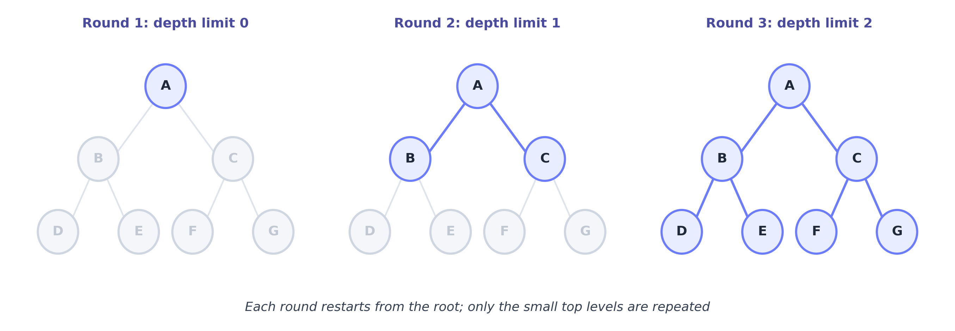
Figure 1.5. Iterative deepening runs a sequence of depth-limited searches. Each round restarts from the root, and only the small upper levels are repeated, so the total work stays close to that of a single breadth-first pass.
Because of this balance, IDS is usually the preferred blind-search method for large problems: it keeps the low memory of DFS while retaining the completeness and, for equal step costs, the optimality of BFS.

Comparing the Four Methods
Method | Complete? | Optimal? | Time | Space | Frontier
Breadth-first (BFS) | Yes | Yes, for equal step costs | $O(b^{d})$ | $O(b^{d})$ | FIFO queue
Uniform-cost (UCS) | Yes | Yes, for any non-negative costs | $O(b^{1+⌊C^{*}/ϵ⌋})$ | same | Priority queue on $g$
Depth-first (DFS) | No | No | $O(b^{m})$ | $O(bm)$ | LIFO stack
Iterative deepening (IDS) | Yes | Yes, for equal step costs | $O(b^{d})$ | $O(bd)$ | LIFO stack, restarted

1.8 Informed Search: Using a Hint
Blind search spreads effort in all directions. In the classroom example, however, the search was not blind; there was a sense that one corridor was closer to the goal. That sense is a heuristic.
A heuristic function, written $h(n)$, is an estimate of the cost from a node $n$ to the goal. It is a hint, not a promise. For a map, a natural heuristic is the straight-line distance to the destination, which is easy to compute and is always a sensible under-estimate of the true road distance.
Three symbols are worth fixing in mind. The quantity $g(n)$ is the cost from the start to $n$, which is already known and paid. The quantity $h(n)$ is the estimated cost from $n$ onward to the goal, which is still a guess. Their sum, $f(n)=g(n)+h(n)$, is the estimated cost of the whole route that passes through $n$.
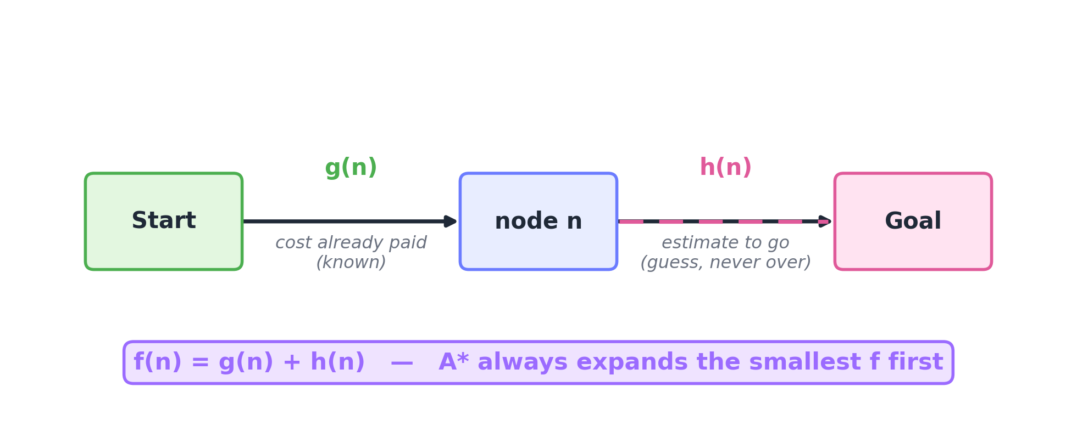
Figure 1.6. The core of A* search: $f(n)=g(n)+h(n)$. The solid arrow $g$ is the cost already spent, which is known. The dashed arrow $h$ is the estimate of the cost still to come.

Greedy Best-First Search
Greedy best-first search expands the node with the smallest $h(n)$, the one that appears closest to the goal. It is quick and often finds a solution rapidly. But like a hurried traveller who always walks straight toward the destination, it can be lured into a long detour, and it is neither optimal nor complete.

A* Search
A* search, pronounced “A-star”, corrects greedy search with one small but powerful change. Instead of minimising $h(n)$ alone, it minimises
$$f(n)=g(n)+h(n).$$
In words, this is the cost already spent plus the estimated cost still to come. A* balances where it has been against where it is going. It neither rushes blindly toward the goal nor wanders cheaply forever; it works to keep the whole journey short. This is the method behind route-finding in maps, movement in games, and navigation in robots, and it is among the most important single ideas in classical AI.
A* is guaranteed to return the cheapest solution when its heuristic satisfies two conditions.
The first condition is admissibility. The heuristic $h(n)$ must never overestimate the true remaining cost. Writing the true remaining cost as $h^{*}(n)$, admissibility means
$$h(n)≤h^{*}(n) \text{for every node }n.$$
Straight-line distance is admissible, because a straight line is the shortest possible path and the real road can only be longer. An admissible heuristic is optimistic; it never frightens the search away from a route that is actually good.
The second condition is consistency, sometimes called monotonicity. For every node $n$ and every neighbour $n′$ reached by an action of cost $c$,
$$h(n)≤c+h(n′).$$
This is a form of the triangle inequality, the familiar rule that a direct route is never longer than a detour: the estimate from $n$ should not exceed the cost of the step to $n′$ plus the estimate from $n′$. Consistency implies admissibility, and it guarantees that A* stays optimal even when searching a graph with an explored set.
The claim that admissibility gives optimality can be shown with a short argument. Suppose, for contradiction, that A* is about to return a goal $G_{2}$ whose path cost $g(G_{2})$ exceeds the true optimal cost $C^{*}$. Because A* has not finished, some node $n$ lying on the genuinely optimal path is still on the frontier. For that node,
$$f(n)=g(n)+h(n)≤g(n)+h^{*}(n)=C^{*}.$$
The inequality uses admissibility, and the final equality holds because $n$ sits on the optimal path, so its cost-so-far plus its true cost-to-go equals the optimal total. For the too-expensive goal $G_{2}$, the heuristic is zero, since it is a goal, so
$$f(G_{2})=g(G_{2})+0=g(G_{2})>C^{*}.$$
Combining the two lines gives $f(n)≤C^{*}<f(G_{2})$, so $n$ has a smaller value of $f$ than $G_{2}$. But A* always expands the smallest $f$ first, so it would have expanded $n$ before $G_{2}$, contradicting the assumption. Therefore A* with an admissible heuristic never returns a too-expensive goal, and so it is optimal.
That argument is worth reading twice, because it does not merely assert the guarantee; it explains why the guarantee must hold.
Key idea. A* is uniform-cost search with a hint added. If $h(n)$ is zero everywhere, meaning no hint at all, A* becomes exactly UCS. The closer an admissible heuristic comes to the true remaining cost, the fewer nodes A* explores, and a perfect heuristic would lead straight to the goal.
A common misconception. It is tempting to think a larger heuristic is always better. It is better, but only while it stays admissible. The moment $h(n)$ exceeds the true cost at some node, A* may overestimate a good route, pass it by, and return a worse answer. A stronger hint helps; a dishonest hint is harmful.
Method | Chooses the smallest | Complete? | Optimal? | Comment
Greedy best-first | $h(n)$ | No | No | Fast but easily misled
A* | $f=g+h$ | Yes | Yes, with an admissible $h$ | The standard choice
Uniform-cost | $g(n)$ | Yes | Yes | The same as A* with $h=0$

1.9 Why Search Appears Everywhere
A whole chapter has been spent on search, and the investment pays off, because search is not one topic within AI so much as a foundation beneath many of them.
In game playing, a program searches a tree of possible moves, using the same frontier idea, though now an opponent is also choosing moves, through a method called minimax that a later chapter develops. In logical reasoning, the subject of the next unit, proving a statement means searching for a chain of steps that leads from known facts to the conclusion, and the methods known as forward and backward chaining are search strategies in another guise. In machine learning, the subject of a later unit, training a model means searching the space of possible settings for the one that fits the data best, and the widely used method of gradient descent is a guided search in which the direction of steepest improvement plays the role of a hint. In planning and robotics, a robot arm searches the space of its joint angles for a path that avoids collisions. In natural language processing, the subject of the final unit, choosing the most likely sentence is a search over sequences of words.
Key idea. A large part of AI reduces to one of two activities: searching a space of possibilities, or learning a function from data. This chapter has built the first of those foundations, and later chapters lean on it repeatedly.

1.10 How Search Is Used in Practice
Search is not a classroom exercise alone. The following are real deployments, each noting the role search actually plays.
Navigation systems compute driving routes across road networks the size of continents in a few thousandths of a second, using A* together with precomputed shortcuts. Ride-hailing services match drivers to riders and plan pickup and drop routes that reduce waiting and travel time. Food-delivery platforms decide which orders a single rider should carry and in what order to deliver them, which is a routing problem. Railway operations assign trains to tracks and platforms without conflict, using constrained search. Space agencies plan spacecraft manoeuvres and schedule contact with ground stations by searching over sequences of options for fuel-efficient choices. Warehouse robots plan collision-free paths for thousands of machines moving shelves at once. Game-playing programs have defeated world champions by combining tree search with learned evaluation. Logistics companies plan multi-stop delivery routes, a classic search problem. In video games, characters move around obstacles using A*. In cyber security, search explores the moves an attacker could make through a network so that weaknesses can be closed first. In healthcare, radiotherapy planning searches over beam angles to concentrate dose on a tumour while sparing healthy tissue. In power grids and cities, search finds low-loss paths for electricity and low-congestion timings for traffic signals. In air travel, search assigns crews and gates under many simultaneous constraints.
Each of these is, at heart, the same task: explore a large space of options and return the best workable one.

1.11 Search in Python, Line by Line
Reading about a method is one thing; building it makes it concrete. The two programs below construct BFS and A* on the small road map. They use only the standard Python library, so nothing needs to be installed.

Representing the graph
# The map as a dictionary: each city maps to its neighbours and road costs.
# graph[city] = list of (neighbour, step_cost) pairs.
graph = {
"Arad": [("Sibiu", 140), ("Timisoara", 118), ("Zerind", 75)],
"Zerind": [("Arad", 75), ("Oradea", 71)],
"Oradea": [("Zerind", 71), ("Sibiu", 151)],
"Sibiu": [("Arad", 140), ("Oradea", 151), ("Fagaras", 99), ("RV", 80)],
"Fagaras": [("Sibiu", 99), ("Bucharest", 211)],
"RV": [("Sibiu", 80), ("Pitesti", 97)], # RV = Rimnicu Vilcea
"Pitesti": [("RV", 97), ("Bucharest", 101)],
"Timisoara": [("Arad", 118)],
"Bucharest": [("Fagaras", 211), ("Pitesti", 101)],
}
The state space is stored as a dictionary of neighbour lists. Each key is a city, that is a state, and its value lists the connected cities together with the cost of reaching them. This single structure encodes the actions, the transition model, and the path cost described in Section 1.6.

Breadth-first search
from collections import deque # deque is a fast double-ended queue
def bfs(graph, start, goal):
# The frontier is a FIFO queue; each item is the whole path taken so far.
frontier = deque([[start]]) # begin with a path containing only 'start'
explored = set() # states already expanded
while frontier: # continue until nothing is left to explore
path = frontier.popleft() # FIFO: take the oldest path, the shallowest
node = path[-1] # the current city is the last one in the path
if node == goal: # goal test
return path # success: return the whole route
if node in explored: # skip states already handled
continue
explored.add(node) # mark this state as expanded
for neighbour, _cost in graph[node]: # expand: generate the children
if neighbour not in explored:
frontier.append(path + [neighbour]) # add the extended path at the back
return None # empty frontier means no path exists
print(bfs(graph, "Arad", "Bucharest"))
# -> ['Arad', 'Sibiu', 'Fagaras', 'Bucharest'] (fewest cities, not the cheapest distance)
The decisive line is frontier.popleft(), which removes from the front, that is the oldest item, and this is what makes the search breadth-first. Replacing it with frontier.pop(), which removes the newest item, turns this same program into depth-first search. That one change is the whole difference between the two methods.

A* search with a heuristic
import heapq # heapq provides a priority queue, a heap that yields the smallest item
# Straight-line-distance heuristic to Bucharest; these values under-estimate real distance.
h = {
"Arad": 366, "Zerind": 374, "Oradea": 380, "Sibiu": 253,
"Fagaras": 176, "RV": 193, "Pitesti": 100, "Timisoara": 329,
"Bucharest": 0,
}
def astar(graph, start, goal, h):
# The priority queue is ordered by f = g + h. Each item is (f, g, path).
frontier = [(h[start], 0, [start])] # g is 0 at the start
explored = set()
while frontier:
f, g, path = heapq.heappop(frontier) # remove the node with the smallest f
node = path[-1]
if node == goal:
return path, g # return the route and its true cost g
if node in explored:
continue
explored.add(node)
for neighbour, cost in graph[node]:
if neighbour not in explored:
g_new = g + cost # cost so far plus this step
f_new = g_new + h[neighbour] # f = g + h, the A* rule
heapq.heappush(frontier, (f_new, g_new, path + [neighbour]))
return None, float("inf")
print(astar(graph, "Arad", "Bucharest", h))
# -> (['Arad', 'Sibiu', 'RV', 'Pitesti', 'Bucharest'], 418) (the cheapest route)
The two programs return different routes on purpose. BFS returns the route with the fewest cities, three hops through Fagaras, while A* returns the route with the fewest kilometres, 418 km through Rimnicu Vilcea and Pitesti. That contrast, fewest steps against cheapest cost, is exactly why heuristics and the sum $g+h$ are needed.
In everyday work, search is rarely coded by hand. Graph libraries provide ready-made shortest-path and A* functions, robotics toolkits provide motion planners, and machine-learning frameworks run search-like optimisation internally. Knowing the underlying method, as you now do, is what makes it possible to use these tools wisely and to diagnose them when they behave oddly.

1.12 Misconceptions Worth Clearing Up
A few beliefs trip up newcomers, and naming them helps.
The belief that BFS is bad because it is slow misses the real issue. BFS explores a great deal, which feels slow, but its true difficulty is memory, $O(b^{d})$, and it usually exhausts memory before it exhausts time.
The belief that DFS finds the shortest path is false. DFS reaches a goal quickly, which feels efficient, but it returns the first path it happens to find, which is usually not the cheapest, so DFS is not optimal.
The belief that A* is always fastest is only half true. A* is only as good as its heuristic. A weak heuristic makes it crawl like UCS, and a heuristic that overestimates can make it return a wrong answer.
The belief that a larger heuristic is always better holds only while the heuristic stays admissible. Once it overestimates, optimality is lost.
The belief that uniform-cost search and BFS are the same holds only when all step costs are equal. When costs differ, cheapest-first and shallowest-first part ways.
The belief that the heuristic equals the actual remaining distance confuses estimate with truth. The heuristic $h(n)$ is only an estimate; the true remaining cost $h^{*}(n)$ is generally unknown, which is the whole reason an estimate is needed.
The belief that rational means perfect overstates the word. Rational means the best decision given the information available, which can still turn out badly.

1.13 Questions to Test Understanding
The following questions capture the ideas most worth being able to explain in your own words.
What is the difference between BFS and DFS, and when is each preferable? BFS explores level by level with a queue; it is complete and, for equal costs, optimal, but it needs $O(b^{d})$ memory. DFS descends with a stack; it uses only $O(bm)$ memory but is neither optimal nor complete in an infinite space. BFS suits shallow solutions when memory is available, while DFS suits tight memory, or deep trees where any solution will do.
Why is A* optimal, in one sentence? Because an admissible heuristic never overestimates, every node on the optimal path keeps $f≤C^{*}$, which is smaller than the $f$ of any too-expensive goal, so the optimal path is always expanded first.
What is a heuristic, and what makes it admissible? A heuristic $h(n)$ estimates the cost from $n$ to the goal, and it is admissible when it never overestimates the true cost, that is $h(n)≤h^{*}(n)$. Admissibility guarantees A*’s optimality on a tree, and consistency guarantees it on a graph.
Which method underlies a maps application, and why? In essence A* with a straight-line-distance heuristic, because the cheapest route is wanted and the heuristic greatly narrows the search compared with a blind method. Production systems add precomputed shortcuts, but the underlying idea is A*.
What are PEAS, and why begin there? Performance, Environment, Actuators, and Sensors are the four things that specify an agent’s task. One begins there because rationality is defined relative to a performance measure, so without PEAS there is no way to say what doing well would mean.

1.14 Notes for Competitive-Examination Preparation
For readers preparing for objective examinations such as GATE Data Science and Artificial Intelligence, the ideas in this chapter appear frequently, and understanding them removes most of the difficulty.
The topics that recur are the time and space costs of BFS, DFS, IDS, UCS, and A*; whether a given method is complete or optimal; the tracing of UCS or A* on a small graph with given costs and a heuristic table, to report either the returned path or its cost; and checks of whether a heuristic is admissible or consistent.
A few points cause trouble if overlooked. A step of cost zero breaks the optimality guarantee of UCS, which needs every step to cost more than zero. BFS is optimal only when all steps cost the same, so a graph with unequal costs, in which the shallowest goal is not the cheapest, is a natural point of confusion. A heuristic can match the true cost at most nodes yet overestimate at a single node, and that one violation is enough to make it inadmissible. Greedy best-first search is not optimal; only A* is, and only with an admissible heuristic.
When tracing A*, a small table of node, $g$, $h$, and $f$ kept as the search proceeds prevents almost all arithmetic slips, since errors usually come from mental arithmetic rather than from the method. For questions about memory, recall the space column: BFS and UCS need $O(b^{d})$, DFS needs $O(bm)$, and IDS needs $O(bd)$. When asked whether UCS or A* explores fewer nodes, the answer with an admissible heuristic is A*, since a hint can only help.
One reading point saves marks quietly: in numerical A* questions the quantity asked for is almost always the path cost $g$ at the goal, not the number of nodes expanded, so it is worth checking which is being requested.

1.15 Exercises
Introductory
- Define in one line each: state space, frontier, goal test, path cost.
- For a tree with branching factor $b=3$ and a goal at depth $d=4$, how many nodes does BFS generate in the worst case? Use $\frac{b^{d+1}−1}{b−1}$.
- Name the data structure used for the frontier in BFS, DFS, UCS, and A*.
Intermediate
- On the road map of Section 1.11, trace UCS from Arad to Bucharest by hand. List the order in which nodes are expanded and give the final path cost.
- Write a PEAS description for an agent that detects fraud in digital payments.
- Explain why IDS has the same time cost $O(b^{d})$ as BFS despite re-exploring the upper levels, and show the summation.
- Classify the environment of online chess against a person on a timer along all six axes.
Advanced
- Prove that if a heuristic $h$ is consistent, meaning $h(n)≤c(n,a,n′)+h(n′)$, then it is admissible. Use induction on the number of steps from $n$ to the goal.
- Construct a small graph and a heuristic that is admissible but not consistent, and show that A* on a tree still returns the optimal path.
- Given two admissible heuristics $h_{1}$ and $h_{2}$, show that $h(n)=\text{max}\{h_{1}(n),h_{2}(n)\}$ is also admissible, and argue why it is at least as good as either one alone.
Conceptual
- A delivery service handles ten thousand orders an hour on servers with limited memory. Would BFS or IDS suit route planning better? Justify the choice using the space costs.
- Explain why a heuristic that overestimates can still be useful in practice, for example in a game that needs a good move quickly rather than the perfect move.

Selected Solutions and Hints
Exercise 2. $\frac{3^{5}−1}{3−1}=\frac{242}{2}=121$ nodes.
Exercise 4. The path is Arad, Sibiu, Rimnicu Vilcea, Pitesti, Bucharest, at cost $140+80+97+101=418$. UCS and A* agree here, whereas BFS would return the three-hop route through Fagaras at cost 450.
Exercise 6. The total is $\sum_{i=0}^{d}{(}d−i+1) b^{i}$. The last level, $b^{d}$, dominates and is explored once; the lower levels add only a constant-factor overhead, leaving $O(b^{d})$.
Exercise 8. For the base case, a goal node has $h=0≤h^{*}=0$. For the inductive step, if $h(n′)≤h^{*}(n′)$ for a node one step closer to the goal, then $h(n)≤c+h(n′)≤c+h^{*}(n′)=h^{*}(n)$, so $h$ is admissible.
Exercise 10. Since $h_{1}≤h^{*}$ and $h_{2}≤h^{*}$, their maximum is still at most $h^{*}$, hence admissible. It dominates because the maximum is at least as large as each of $h_{1}$ and $h_{2}$ at every node, and a larger admissible heuristic never expands more nodes.
Exercise 11. IDS is the better choice. Its memory is $O(bd)$ against the $O(b^{d})$ of BFS, so with limited memory and a large branching factor BFS would fail, while IDS keeps optimality for equal costs at negligible extra time.

1.16 Practice Problems, Objective Type
- A search tree has branching factor $b=2$, and the shallowest goal lies at depth $d=10$. Roughly how many nodes, to an order of magnitude, must BFS store in the worst case? The answer is about $2^{10}$, close to one thousand.
- Which of these statements are true? First, DFS is complete in a finite state space. Second, UCS is optimal even with a zero-cost edge. Third, A* with an admissible heuristic is optimal on a tree. Fourth, greedy best-first search is optimal. The true statements are the first and the third. The second fails because UCS needs every step to cost more than zero, and the fourth fails because only A* is optimal.
- The frontier of A* is best implemented as which structure: a FIFO queue, a LIFO stack, a priority queue ordered by $f=g+h$, or a plain list? The answer is a priority queue ordered by $f=g+h$.
- A node $n$ has $g(n)=60$ and $h(n)=25$, and a goal reachable through $n$ has true optimal cost $C^{*}=80$. Is $h$ admissible at $n$? The true remaining cost is $h^{*}(n)=C^{*}−g(n)=20$, and since $h(n)=25$ exceeds 20 the heuristic overestimates, so it is not admissible.
- BFS and UCS return the same result under which condition: the graph is a tree, all step costs are equal, the heuristic is admissible, or never? The answer is when all step costs are equal.

1.17 Summary
Artificial intelligence is the study of building rational agents, systems that perceive their world and act to reach their goals as well as possible. An agent is described by its PEAS, that is Performance, Environment, Actuators, and Sensors, and its world is described by properties such as observable or hidden, deterministic or uncertain, static or changing.
Many AI problems reduce to search. Given a start, a set of actions, a way to recognise arrival through a goal test, and a cost, the task is to find the best route through the state space. Turning a real situation into this five-part form is problem formulation, the most valuable applied skill in the chapter.
Blind, or uninformed, search knows only the problem. BFS explores level by level and is optimal for equal costs but memory-hungry; DFS descends deeply and is thrifty with memory but neither optimal nor complete; UCS expands the cheapest node first and is optimal for any non-negative cost, being the same as Dijkstra’s method; and IDS combines the low memory of DFS with the guarantees of BFS.
Informed, or heuristic, search adds an estimate $h(n)$ of the remaining cost. Greedy search follows $h$ alone and is fast but not optimal, while A* minimises $f=g+h$ and, with an admissible heuristic, is optimal. A* underlies route-finding, games, and robotics.
The essential formulas are
$$f(n)=g(n)+h(n), h(n)≤h^{*}(n) \text{(admissible)}, h(n)≤c+h(n′) \text{(consistent)},$$
with space costs $O(b^{d})$ for BFS and UCS, $O(bm)$ for DFS, and $O(bd)$ for IDS.
Four ideas are worth keeping. Artificial intelligence is the construction of rational agents, and rationality is always relative to a performance measure. Formulation comes before solution: fix the initial state, the actions, the transition model, the goal test, and the path cost. The only difference between search methods is which frontier node is expanded next. And A* is uniform-cost search with an honest hint, where admissibility is what keeps it correct.

1.18 Quick Revision
- Artificial intelligence is the construction of rational agents that act to maximise a performance measure.
- An agent is a function from a history of percepts to an action, $f:P^{*}→A$.
- PEAS stands for Performance, Environment, Actuators, and Sensors.
- The environment axes are: observable, deterministic, episodic, static, discrete, and single-agent.
- A search problem has five parts: initial state, actions, transition model, goal test, and path cost.
- Frontier structures are: a queue for BFS, a stack for DFS, and a priority queue for UCS and A*.
- Among blind methods, BFS is optimal with $O(b^{d})$ space, DFS is thrifty at $O(bm)$ but not optimal, UCS equals Dijkstra’s method, and IDS combines the strengths of both.
- Among informed methods, greedy search minimises $h$ and is not optimal, while A* minimises $g+h$ and is optimal with an admissible $h$.
- Admissible means $h(n)≤h^{*}(n)$, never overestimating; consistent means $h(n)≤c+h(n′)$.
- A* with $h=0$ is exactly UCS, and a perfect heuristic would lead straight to the goal.
- The Turing Test dates from 1950, and the term “artificial intelligence” from 1956.

1.19 Formula Reference
Quantity | Expression | Meaning
Agent function | $f:P^{*}→A$ | a history of percepts maps to an action
Cost so far | $g(n)$ | the cost from the start to $n$
Heuristic | $h(n)$ | the estimated cost from $n$ to the goal
A* evaluation | $f(n)=g(n)+h(n)$ | total estimated cost through $n$
Admissibility | $h(n)≤h^{*}(n)$ | never overestimate
Consistency | $h(n)≤c(n,a,n′)+h(n′)$ | the triangle inequality
BFS node count | $\frac{b^{d+1}−1}{b−1}=O(b^{d})$ | time and space
DFS space | $O(bm)$ | thrifty memory
IDS space | $O(bd)$ | DFS memory with BFS guarantees
UCS time | $O​\left(b^{ 1+⌊C^{*}/ϵ⌋}\right)$ | cost-based effective depth

1.20 Concept Map
The whole chapter fits into a single picture. The idea of search and agents sits at the centre, the surrounding branches are the ideas built along the way, and the branch on the lower right shows where these ideas lead in later chapters.
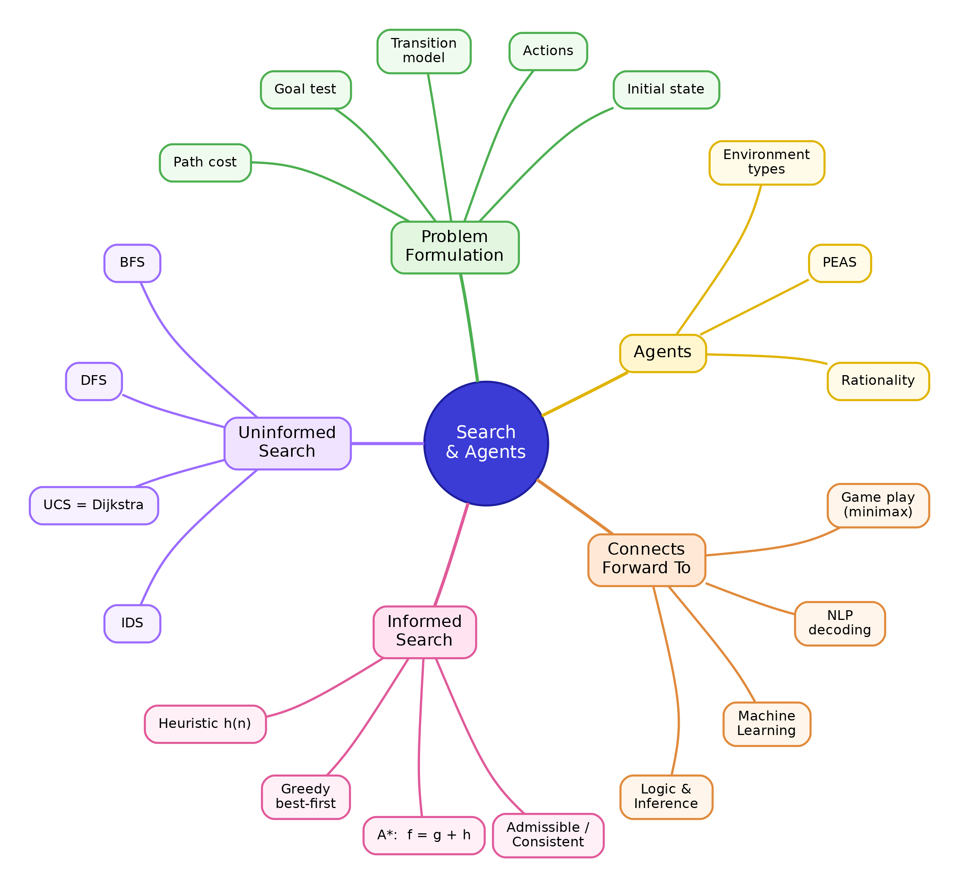
Figure 1.7. A concept map linking the ideas of this chapter to one another and forward to later chapters.
The connections outward are worth stating plainly. This chapter is the foundation, with no chapter before it, and it establishes the agent view that every later topic assumes. The next chapter, on knowledge and reasoning, treats logical inference as a search over proofs, where forward and backward chaining are search strategies. The unit on machine learning treats training as a search through the space of model settings, where the direction of steepest improvement plays the role of a hint. The mathematics of linear algebra and optimisation turns the state space into a continuous one, so that search becomes optimisation over vectors, the same idea of improving step by step toward a goal. And probability and statistics extend deterministic search into decision-making under uncertainty when the environment is not predictable.

1.21 Glossary
Term | Meaning
Agent | A system that perceives its environment through sensors and acts on it through actuators.
Rational agent | An agent that acts to maximise its expected performance measure given its percepts.
PEAS | Performance, Environment, Actuators, Sensors, the specification of an agent’s task.
Percept | A single input the agent observes at one moment.
Performance measure | The criterion that scores how well the agent is doing.
Turing Test | A test in which a machine passes if a person cannot reliably distinguish it from a human in a typed conversation.
State space | The set of all states reachable from the initial state.
Problem formulation | Translating a real problem into an initial state, actions, a transition model, a goal test, and a path cost.
Frontier | The set of nodes generated but not yet expanded.
Explored set | The states already expanded, kept to avoid revisiting and looping.
Branching factor ($b$) | The largest number of children any node can have.
Uninformed search | Search that uses only the problem definition, with no estimate of distance to the goal.
BFS and DFS | Breadth-first search, shallowest first with a queue, and depth-first search, deepest first with a stack.
FIFO and LIFO | First-in first-out, the order of a queue, and last-in first-out, the order of a stack.
UCS | Uniform-cost search, which expands the lowest-cost node first and equals Dijkstra’s algorithm.
IDS | Iterative deepening search, repeated depth-limited search that combines low memory with completeness.
Heuristic ($h(n)$) | An estimate of the cost from a node to the goal.
Admissible heuristic | One that never overestimates the true cost, $h(n)≤h^{*}(n)$.
Consistent heuristic | One that satisfies $h(n)≤c+h(n′)$ for every edge, which implies admissibility.
A* | Informed search that minimises $f=g+h$ and is optimal with an admissible heuristic.
Optimal | Guaranteed to find the least-cost solution.
Complete | Guaranteed to find a solution whenever one exists.
Epsilon ($ϵ$) | The smallest cost any single step may have, required to be greater than zero.
The next chapter keeps the agent view but gives the agent the power to reason with knowledge, representing facts in logic and drawing conclusions, and it will become clear that inference itself is another form of search.

